**Final Project Proposal**

Kaiwen Liu

**Objective:**

This project would be a developed iteration of my mid-term project. The final project will be an ecological combination of fishes and plants. In the mid-term project, temperature and humidity sensors will simply be output through the neo pixel strip and LED matrix, thus reminding people to water or pay attention to the status of plants. In the final project, people do not need to worry about the problem of watering, it will automatically water the plants. And the final project will consider the insolation duration of plants.

**Steps:**

1) Redesign the layout of devices and circuit, warp the exposed wires and Arduino.

2) Add LDR sensors to existing Arduino program. Make sure it works fine.

3) Add water pump to Arduino and Pump water from a fish tank

4) Calculate the total illuminance based on average LDR value per second. Add additional LED light cluster to supplement enough light through LED lights.

5) Integrate all devices and sensors together and set their correlation threshold.

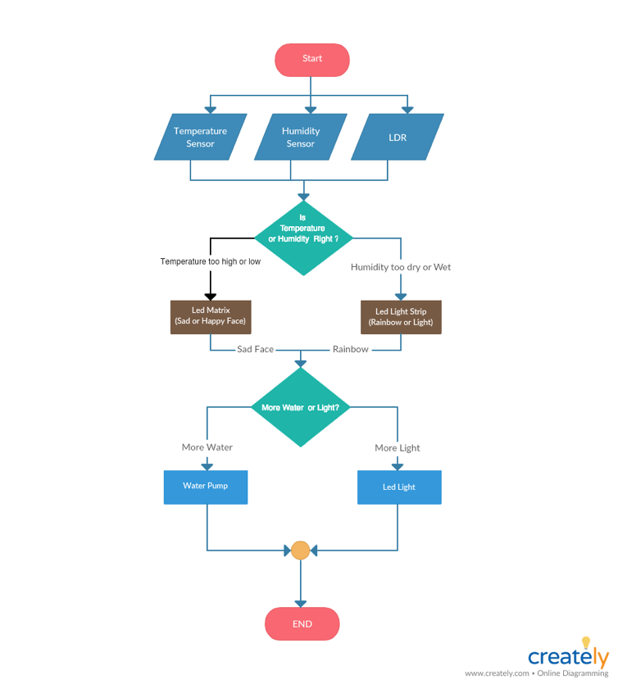**Flow Charts:**

**Nice to have**: Adding an output of speaker, say something like "Hey, your fish need water!" through the speaker.